##### “cutie cat face pencil holder"

##### 

**Price: Rs.900/-**

Soft pencil holder for your table and look amazing.

We take great care in selecting our products. Pretty much everything we sell is sourced from East Asia, home to some of the world's best stationery. Korea and Japan in particular is where most of the stuff we offer is designed and manufactured.

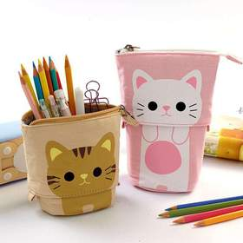

* Model Number: 20785856119
* Type: Holder
* Promotional: No
* Style: Steel made
* Display Screen: show as the picture
* Use: Holders
* Origin: Japan
* Color: white, blue, black.
* Size: 6.5cm x 12cm x15cm
* Type: Accessories